uliya fatima
232098

assignment 1

PENTRATION TESTING

Assignment 1 — Web Setup
Web Hosting • Self-Signed Certificate • Social Engineering Demos

Document Type | Web Security & Phishing Awareness Lab Report
Subject | Web Hosting — Self-Signed Certificate — Social Engineering
Target | localhost (Local Machine) | Apache2 Web Server (Kali Linux)
Platform | Kali Linux
Student ID | 232098_uliya fatima
Classification | Confidential — Internal Use Only
Version | 1.0
Date | March 12, 2026

1. Executive Summary
This assignment demonstrates the setup of a secure web server on Kali Linux with a self-signed SSL certificate. The purpose is to understand how phishing attacks work in a controlled local lab environment. All demonstrations were performed on a local machine only — no real users were targeted and no data was collected externally.

Tools Used:
- Kali Linux (VMware)
- Apache2 Web Server
- OpenSSL (Self-Signed Certificate)
- DVWA (Damn Vulnerable Web Application)
- HTML/CSS (Custom Pages)

── SECTION 1: Web Server Setup ──

Installation apache2 web server:
Apache2 web server was installed on Kali Linux using the apt package manager. Apache is used to host web pages locally on port 80 (HTTP) and port 443 (HTTPS).
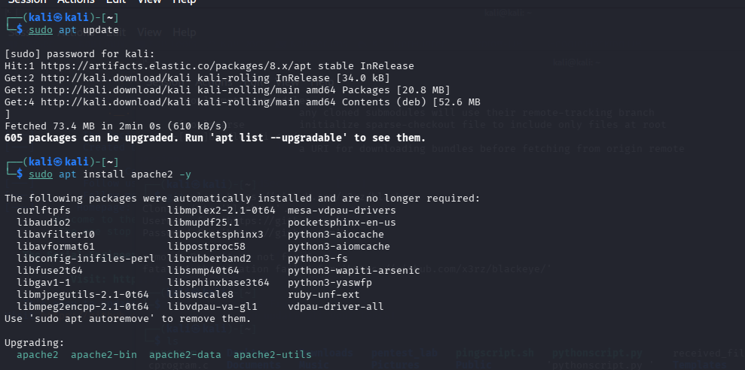
Fig 1.1 — Apache2 web server installed on Kali Linux

Apache Running:
Apache2 service was successfully started and enabled. The status shows "active (running)" confirming the web server is operational and ready to serve web pages.
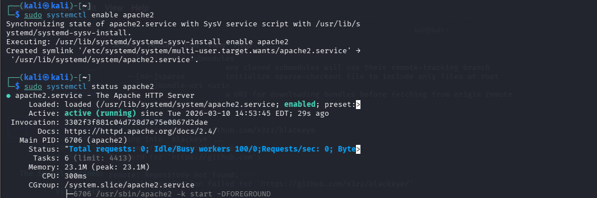
Fig 1.2 — Apache2 service active and running status confirmed

SSL Module Enabled:
The SSL module was enabled in Apache2 using the a2enmod command. This allows Apache to serve encrypted HTTPS connections using SSL/TLS protocol.
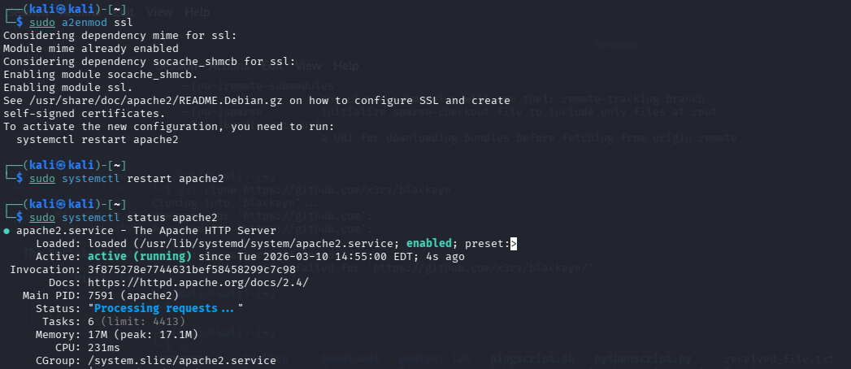
Fig 1.3 — SSL module enabled and Apache restarted successfully

Self-Signed Certificate Creation:
A self-signed SSL certificate was generated using OpenSSL
with the following details:
- Country: PK
- Organization: AIR University
- Common Name: LIYAA
- Validity: 365 days
- Encryption: RSA 2048-bit
This certificate enables HTTPS on our local web server without requiring a Certificate Authority (CA).
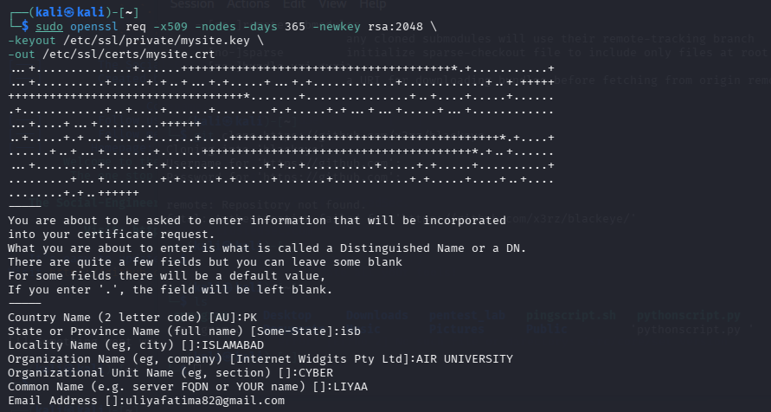
Fig 1.4 — Self-signed certificate created with AIR University details

SSL Certificate Verification:
The self-signed certificate was verified through the browser's Page Info — Security tab. The following details confirm the certificate is working correctly:
- Website: localhost
- Verified by: AIR UNIVERSITY
- Connection: Encrypted (TLS 1.3)
- Encryption: TLS_AES_128_GCM_SHA256, 128-bit keys
This confirms that HTTPS is successfully configured and all data transmitted between the browser and server is encrypted.
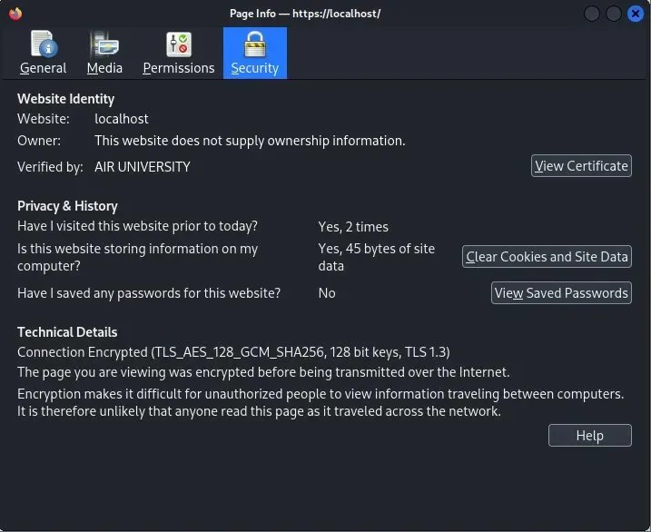

📝 Note: The certificate is self-signed and verified by AIR UNIVERSITY, confirming successful SSL setup on the local Apache web server.

Site Configuration:
A virtual host configuration file was created for the website and enabled using a2ensite command. Apache was reloaded to apply the new SSL configuration.
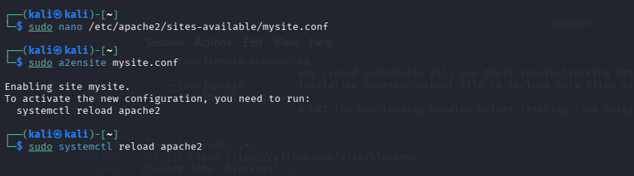

── SECTION 2: Network & DVWA ──

Network Configuration & DVWA Installation:
1. Network Configuration (ip a command):
The 'ip a' command was used to display the network interfaces of the Kali Linux machine. The system shows:
- Loopback interface (127.0.0.1)
- eth0 interface with IP: 192.168.17.128
This IP address is used to access the web server from within the local network.
2. DVWA Installation:
DVWA (Damn Vulnerable Web Application) was installed using apt package manager along with required PHP dependencies including php8.4, MySQL support, and Apache modules DVWA provides a safe environment to practice web application vulnerabilities.
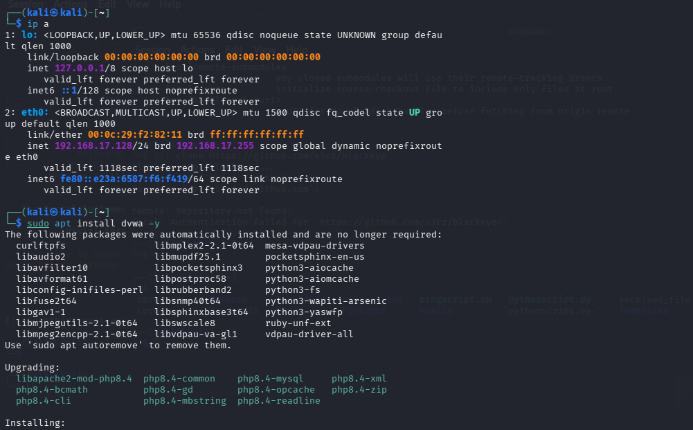

Starting DVWA & Database Services:
Three services were started to make DVWA fully functional:
1. DVWA Service (sudo systemctl start dvwa) Started the DVWA application service.
2. MariaDB Service (sudo systemctl start mariadb) Started the MySQL/MariaDB database which DVWA requires to store user data and vulnerability configurations.
3. Apache2 Restart (sudo systemctl restart apache2) Apache was restarted to ensure all configurations and services are properly loaded and running.
After these steps, DVWA became accessible at:
https://localhost/dvwa
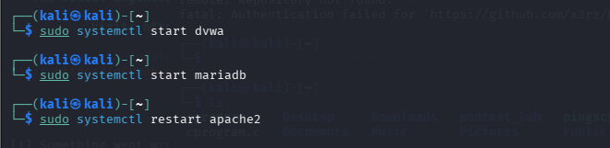
Fig 2.2 — DVWA services started — DVWA, MariaDB and Apache2

DVWA Path Discovery & Web Directory Setup:
After DVWA installation, its location was found using the 'find' command. DVWA files were located at /usr/share/dvwa. A symbolic link was then created to make DVWA accessible through the Apache web server:
- Command: sudo ln -s /usr/share/dvwa /var/www/html/dvwa
- This links DVWA folder to Apache's web root directory
Apache was restarted to apply changes, and the main index.html file was opened for editing using nano editor.
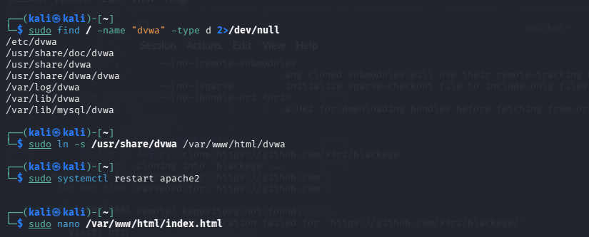
Fig 2.3 — DVWA path discovered and linked to Apache web root

DVWA Login Page:
DVWA was successfully installed and accessible at https://localhost/dvwa. Default credentials were used:
- Username: admin
- Password: password
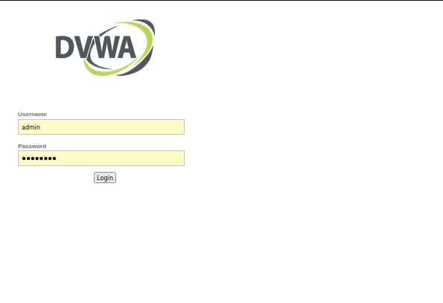
Fig 2.4 — DVWA login page accessible at https://localhost/dvwa

DVWA Dashboard — Vulnerability Modules:
After login, DVWA dashboard shows all available vulnerability modules including Brute Force, SQL Injection, XSS, CSRF and more — confirming complete lab setup.
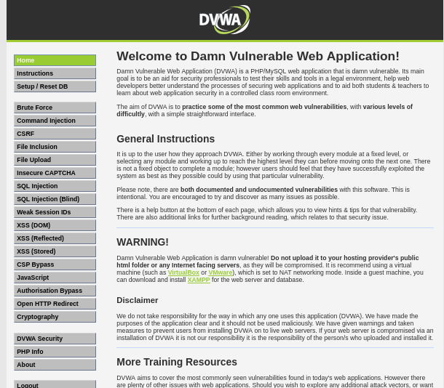
📝 Note: After logging into DVWA, the Setup / Reset DB page was accessed from the left sidebar. The "Create / Reset Database" button was clicked to initialize the database. Upon successful creation, DVWA automatically redirected to the login page confirming the database was configured successfully. Default credentials (admin / password) were used to log back in.

── SECTION 3: Main Web Page ──

Main Web Page — HTML File Creation:
The main web page HTML file was created and edited using the nano text editor in Kali Linux terminal.
Image 1: The file /var/www/html/index.html was opened
using the command:
sudo nano /var/www/html/index.html
Image 2: The HTML code was written inside the nano editor
which includes:
- Custom CSS variables (green hacker theme)
- Google Fonts (Share Tech Mono, Orbitron)
- Matrix rain canvas animation
- Responsive dark background design
- TLS/HTTPS status display
This file serves as the main landing page hosted on the
Apache web server accessible at https://localhost
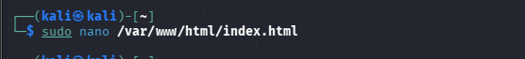
Fig 3.1 — Main web page HTML code in nano editor

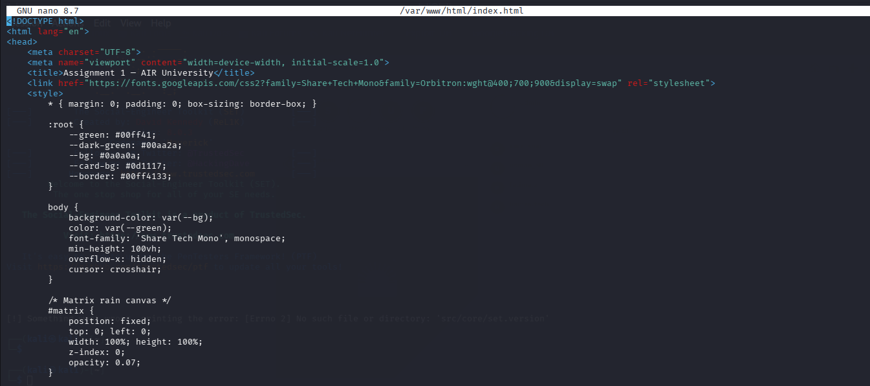
📝 Note: The index.html file was placed in Apache's default web root directory /var/www/html/ making it directly accessible via the browser at https://localhost

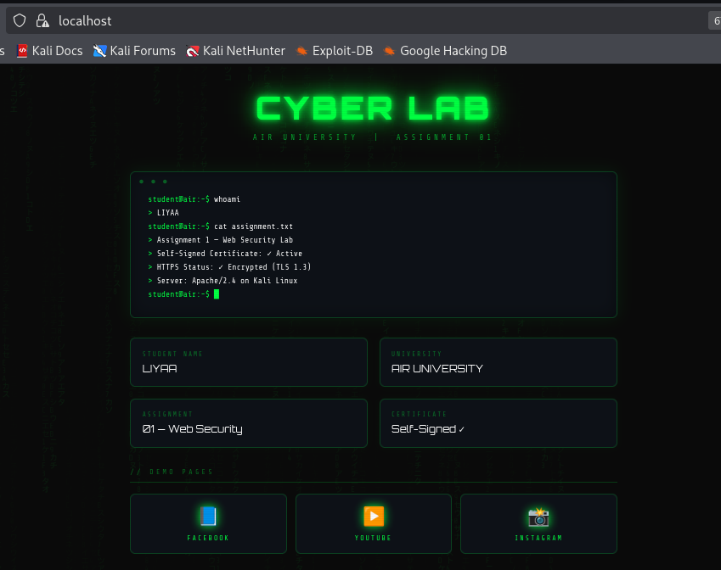
Fig 3.2 — Main Cyber Lab landing page hosted at https://localhost

── SECTION 4: Concept 1 — Facebook ──

Facebook Phishing Page Creation:
A fake Facebook login page was created to demonstrate how phishing attacks work in a controlled lab environment.
Image 2: A new directory and file was created using:
sudo nano /var/www/html/facebook/index.html
Image 1: The HTML/CSS code was written in nano editor
which includes:
- Facebook-style white background (#f0f2f5)
- Lab banner (AIR UNIVERSITY warning)
- Helvetica font matching real Facebook design
- Responsive flexbox layout
- Facebook blue color scheme (#1877f2)
This page is accessible at:
https://localhost/facebook
Fig 4.1 — Facebook phishing page HTML code in nano editor
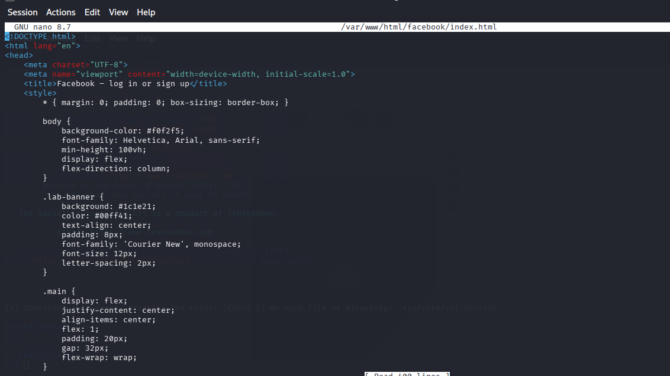
📝 Note: This page was created purely for educational purposes to demonstrate social engineering techniques. It runs only on the local machine — no real credentials were collected or transmitted externally.

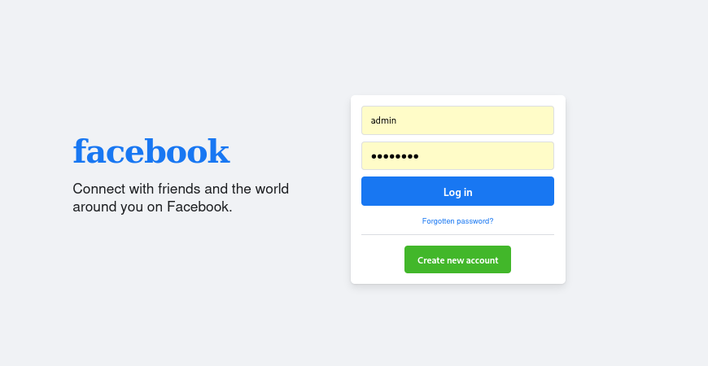
Fig 4.2 — Fake Facebook login page demonstrating phishing concept

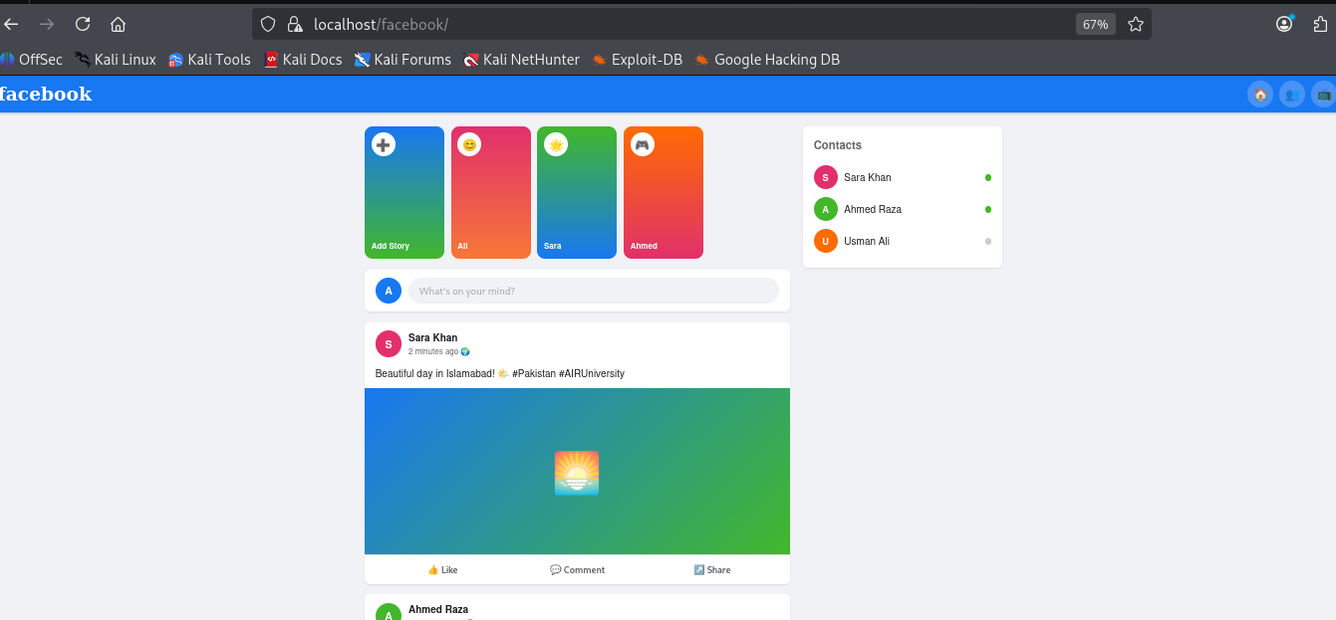
Fig 4.3 — Fake Facebook home feed displayed after login

── SECTION 5: Concept 2 — YouTube ──

YouTube Deceptive Page Creation:
A fake YouTube page was created to demonstrate how deceptive video link mechanisms work in phishing attacks.
Image 2: A new directory and file was created using:
sudo mkdir /var/www/html/youtube
sudo nano /var/www/html/youtube/index.html
Image 1: The HTML/CSS code was written in nano editor
which includes:
- YouTube-style dark background (#0f0f0f)
- Roboto font matching real YouTube design
- Lab banner (AIR UNIVERSITY warning)
- YouTube navbar with search bar
- Video player with play/pause controls
- Recommended videos sidebar
When user clicks play button or any interactive element,a fake Gmail/Google login popup appears automatically.
This page is accessible at:
https://localhost/youtube
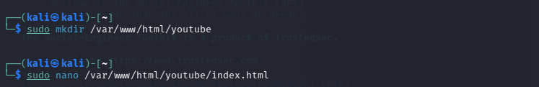
Fig 5.1 — YouTube deceptive page HTML code in nano editor

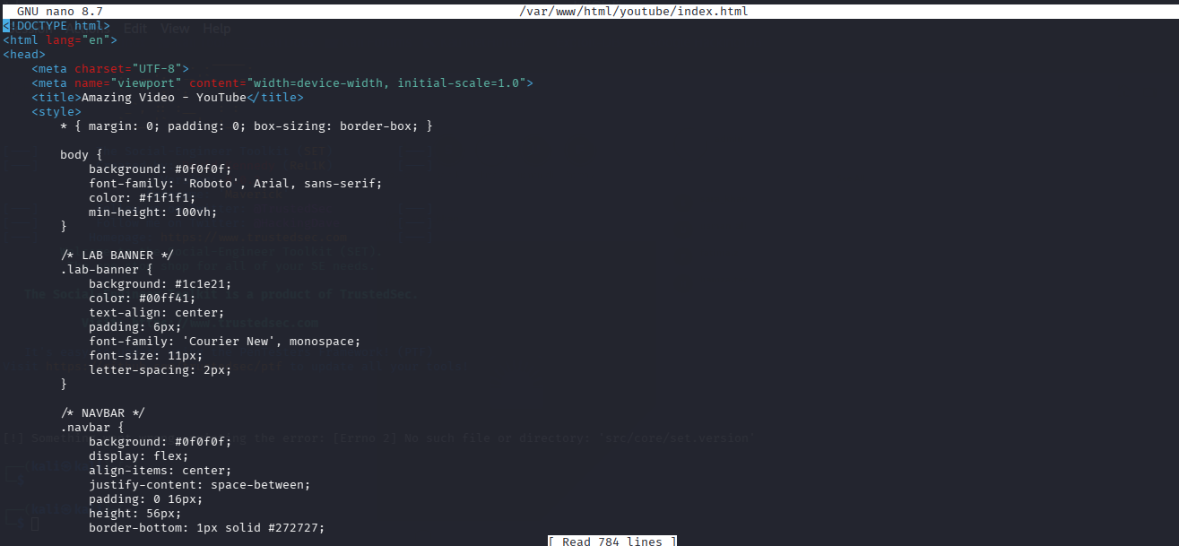
📝 Note: This page demonstrates how attackers embed fake login forms inside legitimate-looking video pages. Any interaction with the video player triggers a Google Sign-in popup — a common social engineering technique used in real phishing campaigns. This demo runs on local machine only.

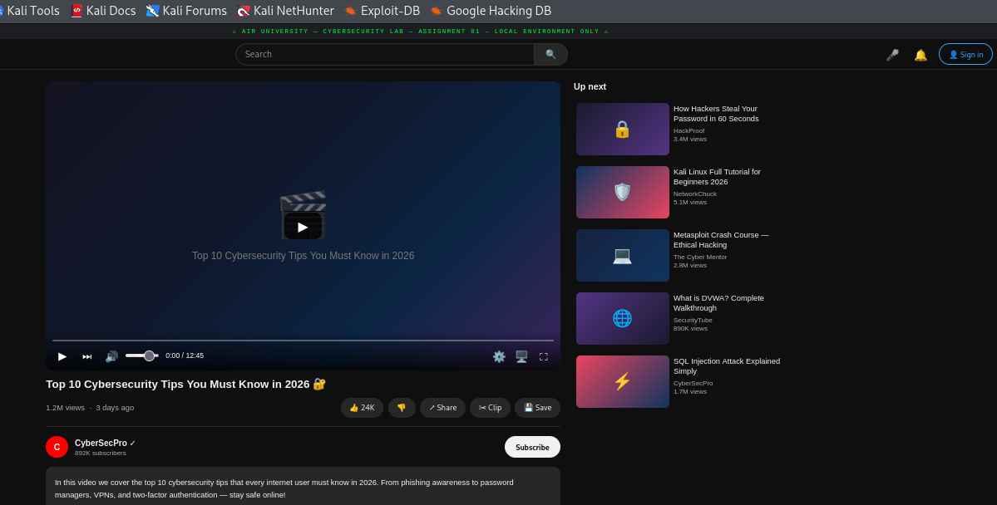
Fig 5.2 — YouTube page full view

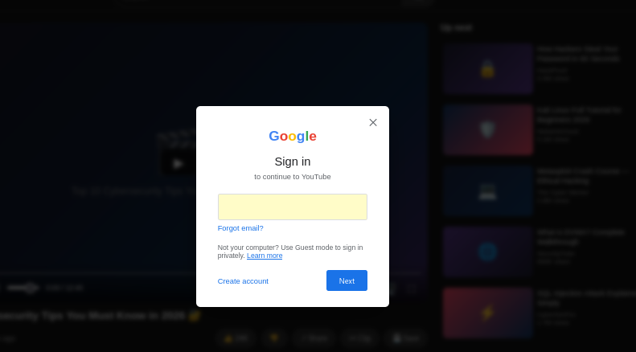
Fig 5.3 — Gmail password step after email entry

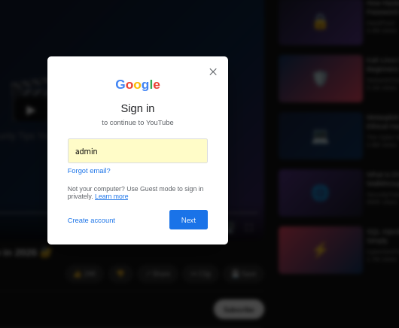
Fig 5.4 — Gmail sign-in flow step 1
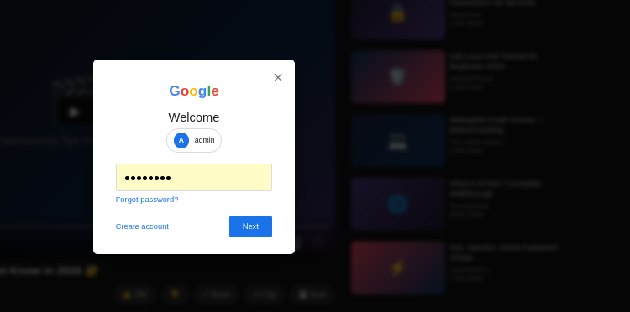
Fig 5.5 — Gmail sign-in flow step 2

── SECTION 6: Bonus — Instagram ──

Instagram Phishing Page Creation:
As an additional demonstration, a fake Instagram login page was created to show how multiple social media platforms can be mimicked in phishing attacks.
Image 2: A new directory and file was created using:
sudo mkdir /var/www/html/instagram
sudo nano /var/www/html/instagram/index.html
Image 1: The HTML/CSS code was written in nano editor
which includes:
- Instagram-style white background (#fafafa)
- Grand Hotel font for Instagram logo styling
- Apple system fonts matching real Instagram design
- Lab banner (AIR UNIVERSITY warning)
- Login page + Home feed after login
This page is accessible at:
https://localhost/instagram
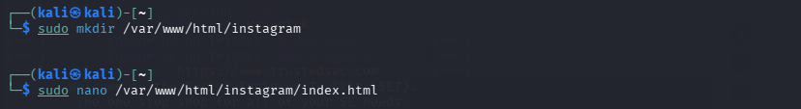
Fig 6.1 — Instagram phishing page HTML code in nano editor
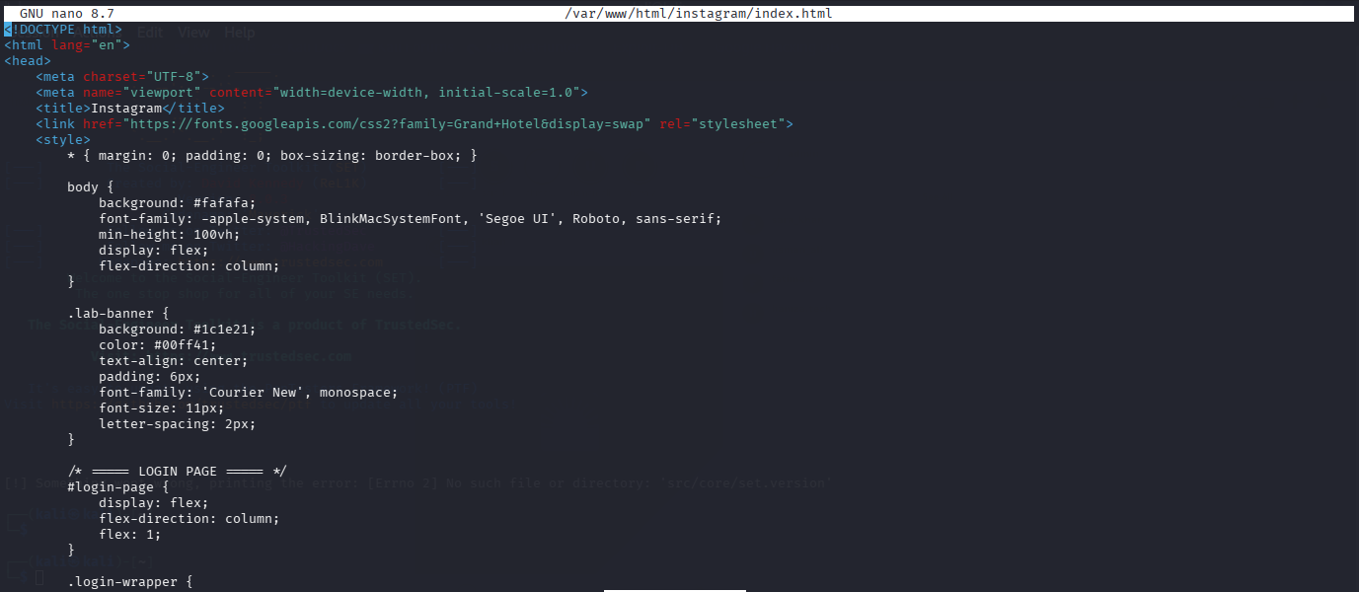
📝 Note: This Instagram page was created as a bonus task beyond the assignment requirements. It further demonstrates how social media phishing pages are designed to look identical to the original platforms. This demo runs on local machine only.
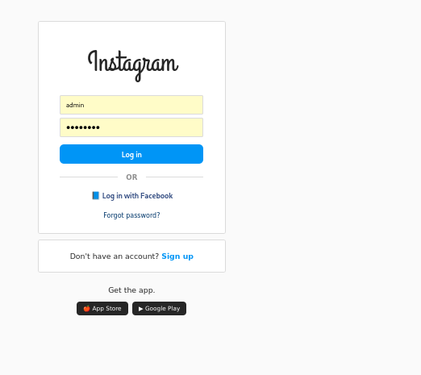
Fig 6.2 — Fake Instagram login page

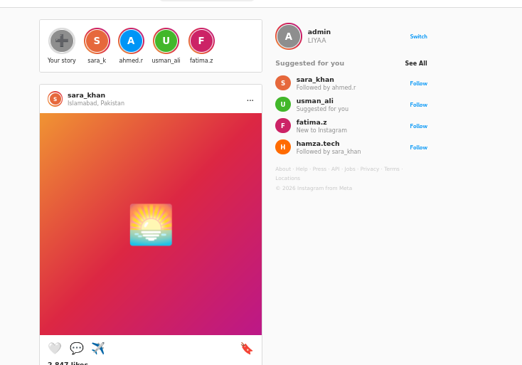
Fig 6.3 — Fake Instagram home feed after login

Actually I’m doing credential harvesting by using toolkit :

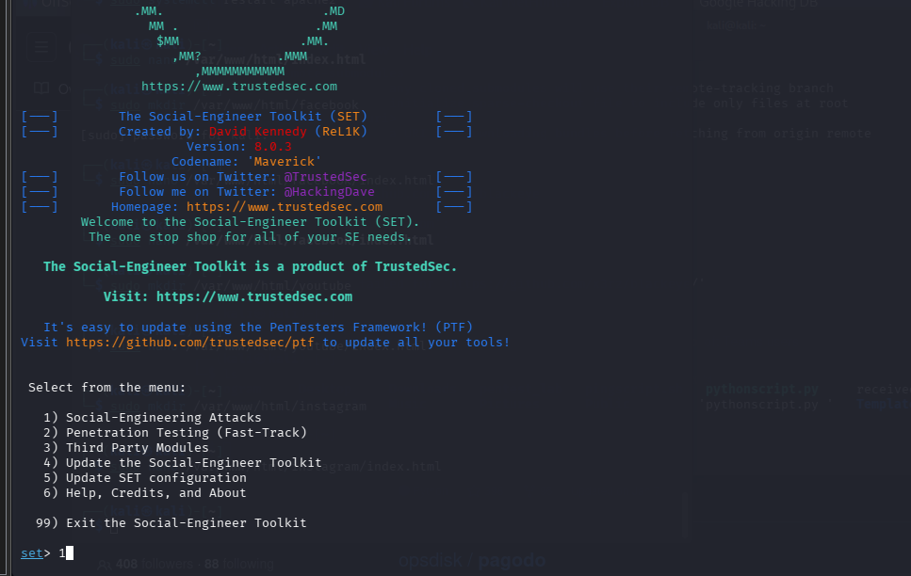Fig 7.1 — Credential harvesting toolkit setup

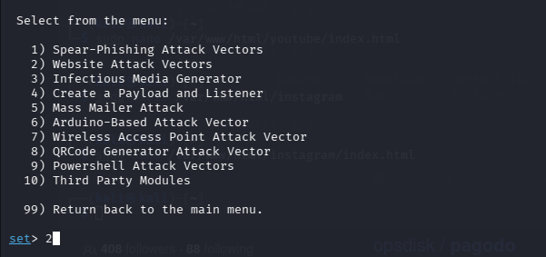
Fig 7.2 — Toolkit execution and phishing link generation

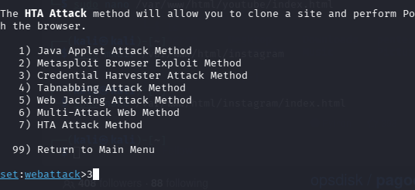
Fig 7.3 — Victim interaction with phishing page

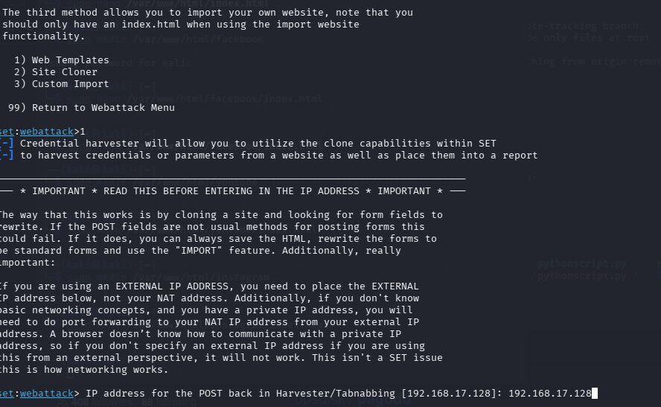
Fig 7.4 — Credentials captured and displayed in terminal

